# **Lesson Objectives**

1. State dimensions of a matrix.
2. Represent a linear system with an augmented matrix (and vice-versa).
3. Solve a linear system using reduced-row echelon form (rref) on calculator.
4. Determine if an ordered pair or ordered triple is a solution to a linear system of equations.
5. Solve applications with a linear system of equations and matrix rref on calculator.

**____________** – a rectangular array of elements, typically surrounded by large brackets

**_________________** of a matrix – ________ × _______________ (RC)

# State the **Dimensions** of a Matrix

* **EXAMPLE:** State the dimensions of the matrix. [6.4-1]

$$\left[\begin{matrix}5 & 5 & -4 \\ 5 & -2 & 9\end{matrix}\right]$$

The dimensions are: **____ × ____**, (“two by three”) which means 2 rows by 3 columns.

# Represent a Linear System with an **Augmented Matrix** (and vice-versa)

**___________________ matrix** – a matrix comprised of all coefficients and constants from a linear system written in STANDARD form.

* **EXAMPLE:** Write the augmented matrix for the system. [6.4-11]

$\left\{\begin{aligned}3x+2z=45 \\ 3y+8z=81 \\ 2x+3y+8z=99\end{aligned}\right.$ (re-write with zeros, as needed) → $\left\{\begin{aligned}3x+____y+2z=45 \\ _____x+3y+8z=81 \\ 2x+3y+8z=99\end{aligned}\right.$

* Line up variables and constants (______________________ form).
* Insert _________________ as placeholders, if needed.
* Use only coefficients and constants.
* Leave behind variables and equals.
* Put large brackets on outside.
* Use vertical bar for all the equals signs.

$\left\{\begin{aligned}3x+0y+2z=45 \\ 0x+3y+8z=81 \\ 2x+3y+8z=99\end{aligned}\right.$ (write as an augmented matrix) →

* **EXAMPLE:** Write the system of equations that the augmented matrix represents. [6.4-15]

$\left[\begin{matrix}9 & 9 & 7 \\ 5 & 0 & 4 \\ 7 & 4 & 0\end{matrix} | \begin{aligned}-2 \\ 4 \\ 2\end{aligned}\right]$ (write as a linear system) → $\left\{\begin{aligned} ____x+____y+____z=-2 \\ 5____+4____=4 \\ 7___+4____=2\end{aligned}\right.$

* First column represents *x*, second is *y*, etc.
* Last column is always for the constants.
* Vertical line is for the equals signs.
* Terms with zero don’t need to be written.

# **Solve** a Linear System **Using** Reduced-Row Echelon Form **(rref) on calculator**

* **EXAMPLE:** The augmented matrix below is in reduced row-echelon form and represents a system of equations. If possible, solve the system. [6.4.65]

|  |  |  |
| --- | --- | --- |
| **What Reduced Row Echelon Form (rref) Looks Like** | | |
|  |  |  |
| Given rref matrix | 1’s along diagonal | Zeros elsewhere |

**Solution** is in the **LAST column** of the matrix, when in reduced row-echelon form (rref).

Translating this rref matrix back into its equation format:

$\left[\begin{matrix}1 & 0 & 0 \\ 0 & 1 & 0 \\ 0 & 0 & 1\end{matrix} | \begin{aligned}-1 \\ 3 \\ \frac{4}{5}\end{aligned}\right]$ (re-write as a linear system) The solution is $\left( , , \right)$.

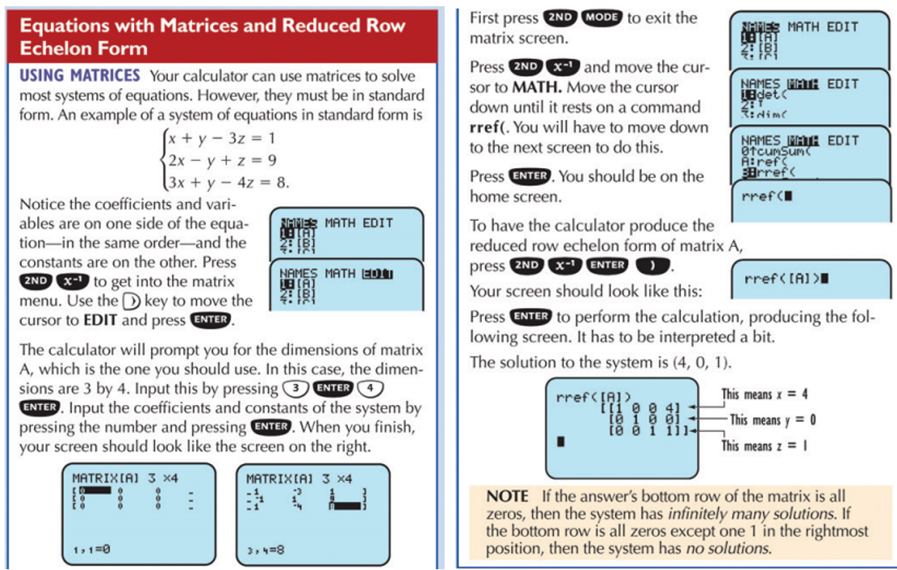

* **EXAMPLE:** Use Gaussian elimination with backward substitution to solve following system of equations.

$\left\{\begin{aligned}-10x-3y=-35 \\ 4x+y=15\end{aligned}\right.$ [6.4.35]

(NOTE: For the following question, solve the linear system using MATRIX method with ________. Do ______ use the Gaussian elimination method as mentioned in the directions.

So, Question Help and/or Skill Builder links will NOT be appropriate for this question.)

$\left\{\begin{aligned}-10x-3y=-35 \\ 4x+y=15\end{aligned}\right.$ (write as an augmented matrix) → $\left[\begin{matrix}-10 & -3 \\ 4 & 1\end{matrix} | \begin{aligned}-35 \\ 15\end{aligned}\right]$

Enter the augmented matrix in the calculator by pressing **_______, *_____***. (MATRIX)

The dimension of the matrix is **___ × ___**. Enter all the values into the matrix on the calculator.

Leave the matrix by pressing **_____, ____** (QUIT).

Press **______, *______***. (MATRIX)**, ____** (MATH), (scroll down) **____________, ENTER.**

Go back into the MATRIX one last time pressing **_____, *____*** (MATRIX)**, ENTER.**

 So the solution is: **( , )**

# **Determine** if an Ordered Pair (or Triple) is **a Solution** to a Linear System

* **EXAMPLE:** Determine if the ordered triple $\left(-\frac{2}{3},1,-\frac{2}{3}\right)$ is a solution of the system of equations. $\begin{aligned}9x-9y-6z=-11 \\ 6x+3y-3z=4 \\ x-y+2z=-3\end{aligned}$ [6.3-2]

One way to do this is similar to what we’ve done previously in Section 6.1, where we ________ _____ the values for *x*, *y*, and *z* from the given point into each of the three equations. The video in the homework demonstrates this as well for your reference.

A much faster way is to determine the solution by using a MATRIX with rref:

$\begin{aligned}9x-9y-6z=-11 \\ 6x+3y-3z=4 \\ x-y+2z=-3\end{aligned}$ (write as an augmented matrix) →

|  |  |  |
| --- | --- | --- |
| Enter your matrix into calculator, then double-check your matrix by pressing **2ND, *x*-1**. (MATRIX)**, ENTER**.  Make corrections, if necessary. | Run the rref command on the calculator. | Press **MATH, ENTER, ENTER** to convert to fractions. |
|  |  |  |

(carried over from previous page) 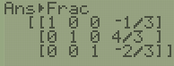

The solution given by rref is $\left(-\frac{1}{3},\frac{4}{3},-\frac{2}{3}\right)$. Recall what the original problem asked:

**Determine whether the ordered triple $\left(-\frac{2}{3},1,-\frac{2}{3}\right)$ is a solution of the system of equations.**

rref matches given point = ________ rref doesn’t match given point = _______

# Solve **Applications** with a Linear System of Equations

* **EXAMPLE:** There were 40,000 people at a ball game in Los Angeles. The day’s receipts were $330,000. How many people paid $12 for reserved seats and how many paid $6 for general admission? [6.1-62]

**Step 1. Define your variables.**

Let *x* = the number of ________________________________________

Let *y* = the number of ________________________________________

**Step 2. Make your equations.**

(Total _________________ equation) *_____* + __*____* = _______________

(Total _________________ equation) _____ + ______= _______________

**Step 3. Convert equations to an augmented matrix.**

$\left\{\begin{aligned}x+y=40,000 \\ 12x+6y=330,000\end{aligned}\right.$ (write augmented matrix) →

**Step 4. Enter augmented matrix (2 × 3) into calculator and do rref to get solution.**

|  |  |
| --- | --- |
| Confirm your augmented matrix | Compute rref ( [ A ] ) |
|  |  |

**Step 5. Interpret your rref ( [ A ] ) solution correctly in context for the answer.**

The solution is (15000, 25000), which means *x* = 15,000 and *y* = 25,000.

**______________________ people purchased $12 reserved seats**

**______________________ purchased $6 general admission.**

Sources Used:

1. Calculator Review Card, page 6 – Equations with Matrices and Reduced Row Echelon Form <https://media.pearsoncmg.com/aw/aw_mml_shared_1/calculator_review_card.pdf>
2. Pearson MyLab Math *College Algebra with Modeling and Visualization, 6th Edition*, Rockswold
3. Wabbitemu calculator emulator version 1.9.5.21 by Revolution Software, BootFree ©2006-2014 Ben Moody, Rom8x ©2005-2014 Andree Chea. Website <https://archive.codeplex.com/?p=wabbit>